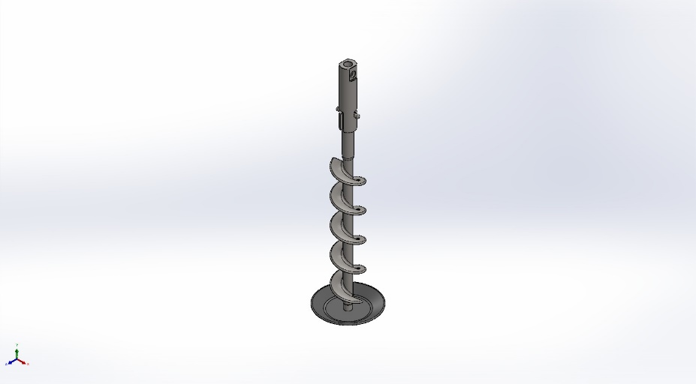
  Simulation of auger and shaft and plate
  Date: Tuesday, January 6, 2026
  Designer: Solidworks
  Study name: auger and shaft and plate analysis
  Analysis type: Static
  Table of Contents
  Description 1
  Assumptions 2
  Model Information 2
  Study Properties 3
  Units 3
  Material Properties 4
  Loads and Fixtures 4
  Connector Definitions 5
  Interaction Information 5
  Mesh information 5
  Sensor Details 5
  Resultant Forces 6
  Beams 6
  Study Results 7
  Conclusion 9

Description
No Data

Assumptions

Model Information

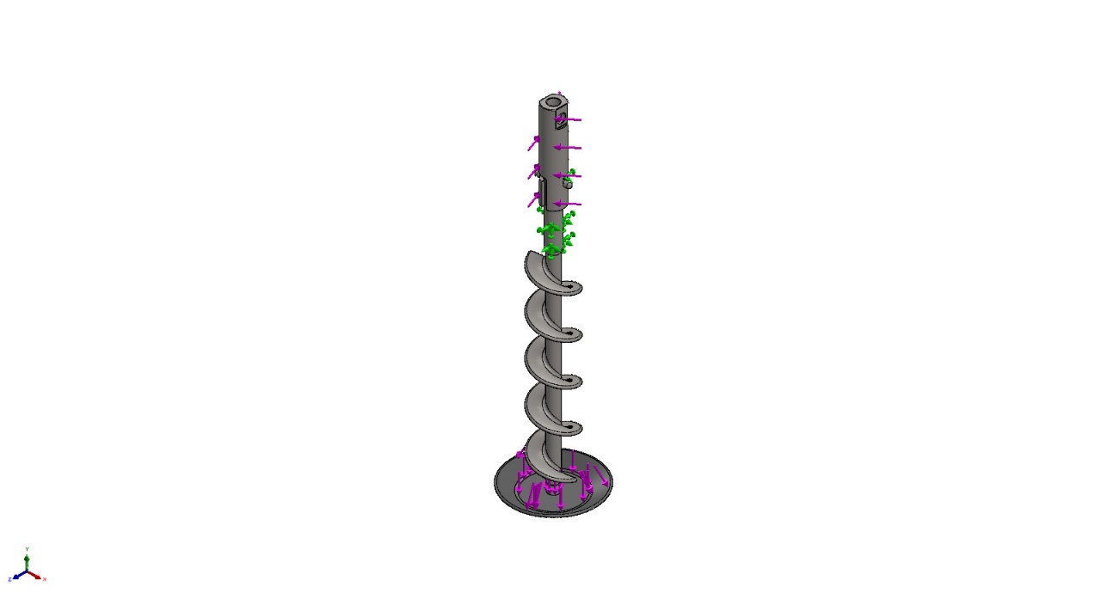
Model name: auger and shaft and plate
Current Configuration: Default
Solid Bodies
Document Name and Reference | Treated As | Volumetric Properties | Document Path/Date Modified
Combine1  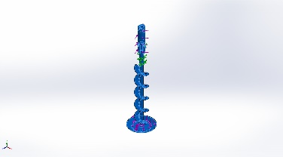 | Solid Body | Mass:1.96918 kg  Volume:0.000246147 m^3  Density:8,000.01 kg/m^3  Weight:19.2979 N | C:\Users\user1\Desktop\VFFS\analysis\solidworks analysis\auger and shaft and pannel\auger and shaft and plate.SLDPRT  Jan 6 21:40:52 2026

Study Properties
Study name | auger and shaft and plate analysis
Analysis type | Static
Mesh type | Solid Mesh
Thermal Effect: | On
Thermal option | Include temperature loads
Zero strain temperature | 298 Kelvin
Include fluid pressure effects from SOLIDWORKS Flow Simulation | Off
Solver type | Automatic
Inplane Effect: | Off
Soft Spring: | Off
Inertial Relief: | Off
Incompatible bonding options | Automatic
Large displacement | Off
Compute free body forces | On
Friction | Off
Use Adaptive Method: | Off
Result folder | SOLIDWORKS document (C:\Users\user1\Desktop\VFFS\analysis\solidworks analysis\auger and shaft and pannel)

Units
Unit system: | SI (MKS)
Length/Displacement | mm
Temperature | Kelvin
Angular velocity | Rad/sec
Pressure/Stress | N/m^2

Material Properties
Model Reference | Properties | Components
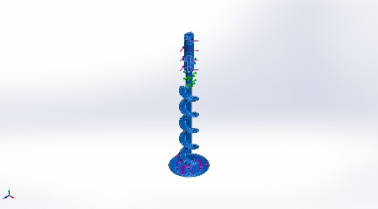 |  | SolidBody 1(Combine1)(auger and shaft and plate)
  Name: | AISI 304
  Model type: | Linear Elastic Isotropic
  Default failure criterion: | Max von Mises Stress
  Yield strength: | 2.06807e+08 N/m^2
  Tensile strength: | 5.17017e+08 N/m^2
  Elastic modulus: | 1.9e+11 N/m^2
  Poisson's ratio: | 0.29
  Mass density: | 8,000 kg/m^3
  Shear modulus: | 7.5e+10 N/m^2
  Thermal expansion coefficient: | 1.8e-05 /Kelvin
Curve Data:N/A

Loads and Fixtures
Fixture name | Fixture Image | Fixture Details
Fixed-1 | 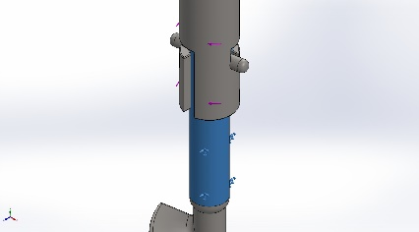
  Entities: | 1 face(s)
  Type: | Fixed Geometry
Resultant Forces
Components | X | Y | Z | Resultant
Reaction force(N) | 1.03046 | 14.1354 | -0.0402193 | 14.173
Reaction Moment(N.m) | 0 | 0 | 0 | 0

Load name | Load Image | Load Details
Torque-1 | 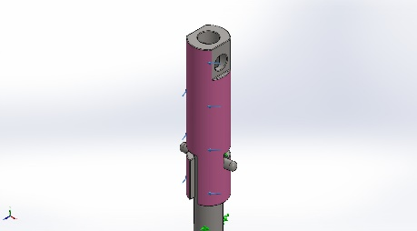
  Reference: | Face< 1 >
  Type: | Apply torque
  Value: | 20 N.m
Force-1 | 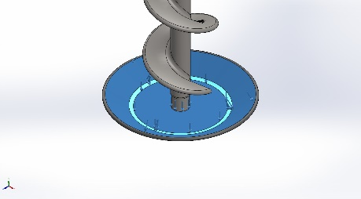
  Entities: | 3 face(s)
  Type: | Apply normal force
  Value: | 5 N

Connector Definitions
No Data

Interaction Information
No Data

Mesh information
Mesh type | Solid Mesh
Mesher Used: | Blended curvature-based mesh
Jacobian points for High quality mesh | 16 Points
Maximum element size | 10.8147 mm
Minimum element size | 0.540736 mm
Mesh Quality | High

Mesh information - Details
Total Nodes | 396630
Total Elements | 256485
Maximum Aspect Ratio | 60.986
% of elements with Aspect Ratio < 3 | 99.1
Percentage of elements with Aspect Ratio > 10 | 0.0378
Percentage of distorted elements | 0
Time to complete mesh(hh;mm;ss): | 00:00:28
Computer name:

Sensor Details
No Data

Resultant Forces

Reaction forces
Selection set | Units | Sum X | Sum Y | Sum Z | Resultant
Entire Model | N | 1.03046 | 14.1354 | -0.0402193 | 14.173

Reaction Moments
Selection set | Units | Sum X | Sum Y | Sum Z | Resultant
Entire Model | N.m | 0 | 0 | 0 | 0

Free body forces
Selection set | Units | Sum X | Sum Y | Sum Z | Resultant
Entire Model | N | 0.0333386 | -0.111271 | 0.0551278 | 0.128576

Free body moments
Selection set | Units | Sum X | Sum Y | Sum Z | Resultant
Entire Model | N.m | 0 | 0 | 0 | 1e-33

Beams
No Data

Study Results

Name | Type | Min | Max
Stress1 | VON: von Mises Stress | 3.330e+00N/m^2  Node: 390858 | 1.069e+08N/m^2  Node: 187154
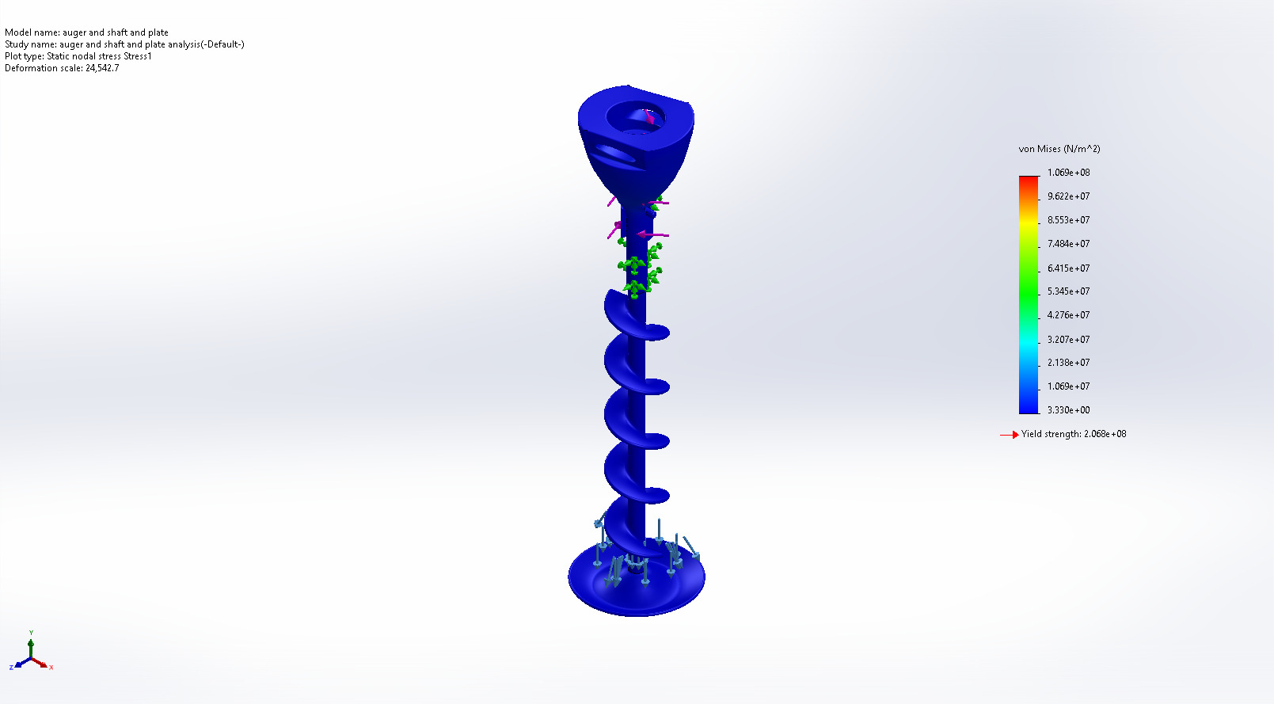
auger and shaft and plate-auger and shaft and plate analysis-Stress-Stress1

Name | Type | Min | Max
Displacement1 | URES: Resultant Displacement | 0.000e+00mm  Node: 136 | 2.128e-03mm  Node: 3638
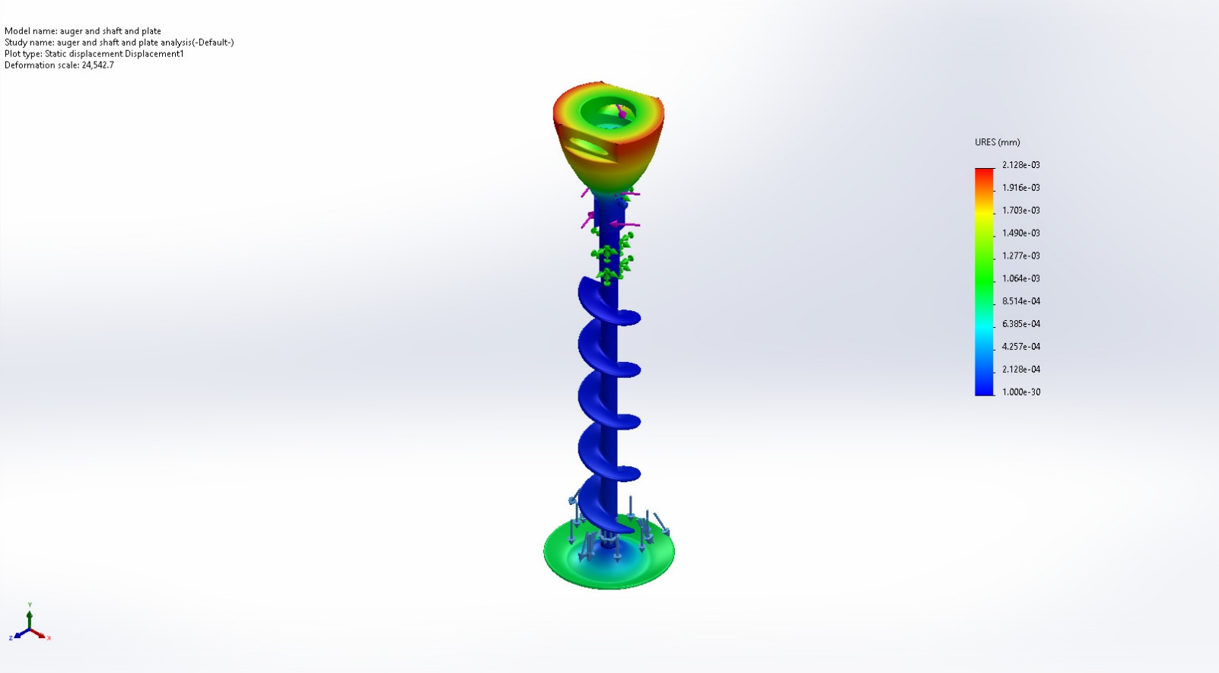
auger and shaft and plate-auger and shaft and plate analysis-Displacement-Displacement1

Name | Type | Min | Max
Strain1 | ESTRN: Equivalent Strain | 1.144e-11  Element: 207212 | 7.504e-04  Element: 55039
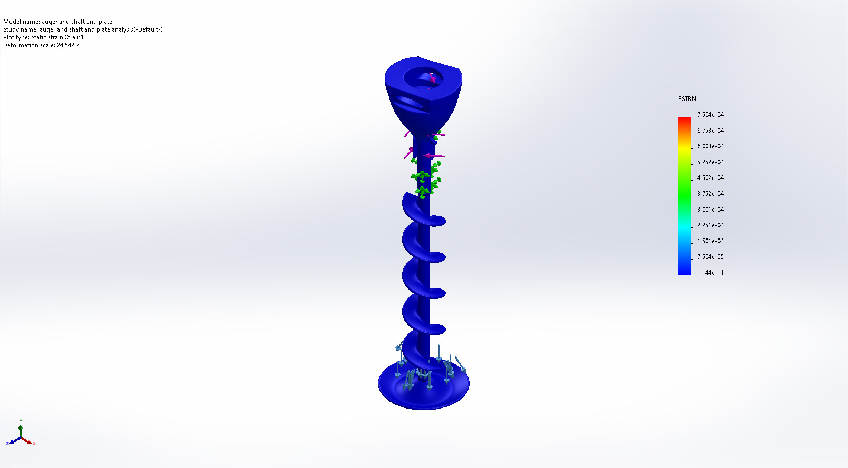
auger and shaft and plate-auger and shaft and plate analysis-Strain-Strain1

Name | Type | Min | Max
Factor of Safety1 | Max von Mises Stress | 1.934e+00  Node: 187154 | 6.210e+07  Node: 390858
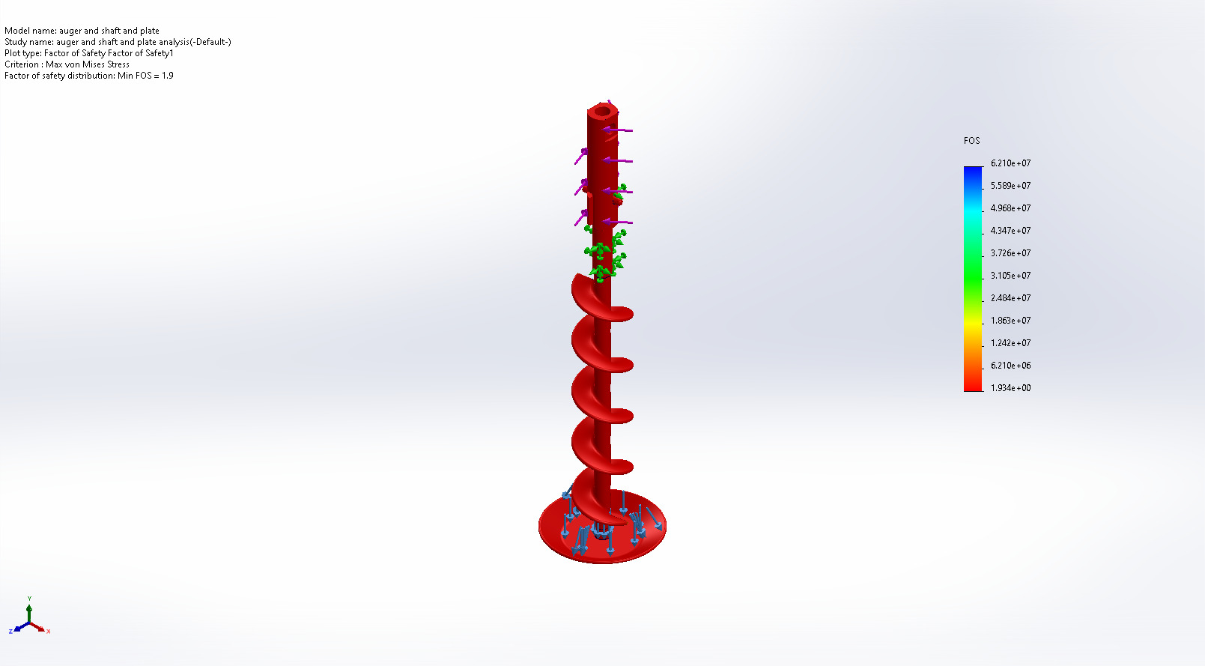
auger and shaft and plate-auger and shaft and plate analysis-Factor of Safety-Factor of Safety1

Conclusion

